S.NO | NAME OF THE TEACHER | DESIGNATION | QUALIFICATION WHETHER HAVING MBA I CLASS | WHETHER HAVING Ph.D DEGREE IN MANAGEMENT | DATE OF BIRTH | TOTAL NO OF YEARS OF EXPERIENCE |  | NATURE OF APPOINTMENT |  |  |  |  |  | PHOTO | DETAILS OF AADHAAR CARD,  PAN CARD,  BANK ACCOUNT NO
 |  |  |  |  |  |  |  | THROUGH O.U SELECTION COMMITTEE |  | MANAG  EMENT |  |  |  | PHOTO
1 | Dr. Mohammed  Masood. | Professor | MBA, PGDCA, MCSE, Ph.D | Yes | ’30-11-1965 | 30 |  |  |  |  |  |  |  | 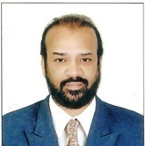 | 227840688784,  AJVPM3941J,  620968147,  INDIAN BANK.
2 | Mr. Dr. SYED SHAFIUDDIN AIJAZ. | Associate Professor | B.Tech ,MBA, Ph.D | Yes | ’21-03-1986 | 09 |  |  |  |  |  |  |  | 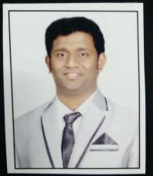 | 339602354416,  DLEPS7729J,  418446576,  INDIAN BANK.
3 | Dr. S.NAYAMATH BASHA | Associate Professor | MBA , M.Phil.,  Ph.D. | Yes | ’01-06-1985 | 11 |  |  |  |  |  |  |  | 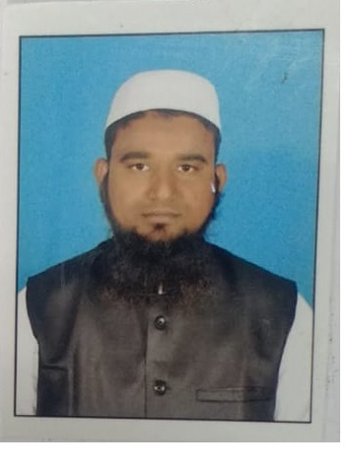 | 597148114625 ,  ASAPB1515F ,  37332415926,  SBI BANK.
S.NO | NAME OF THE TEACHER | DESIGNATION | QUALIFICATION WHETHER HAVING MBA I CLASS | WHETHER HAVING Ph.D DEGREE IN MANAGEMENT | DATE OF BIRTH | TOTAL NO OF YEARS OF EXPERIENCE |  | NATURE OF APPOINTMENT |  |  |  |  |  | PHOTO | DETAILS OF AADHAAR CARD,  PAN CARD,  BANK ACCOUNT NO
 |  |  |  |  |  |  |  | THROUGH O.U SELECTION COMMITTEE |  |  |  | MANAG  EMENT |  | PHOTO
4 | Mr.MD MOIN UDDIN MUDASSIR | Associate Professor | MBA , Ph.D. | Yes | ’25-06-1991’ | 08 |  |  |  |  |  |  |  |  | 476141802188,  BJDPM1769H,  20029463515,  SBI BANK.
5 | Ms. MARIYA BEGUM | Assistant Professor | MBA. | No | ’04-11-1988 | 06 |  |  |  |  |  |  |  | 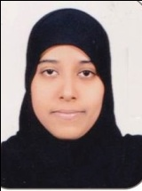 | 685083259339, CHGPB8924B,  30112010111417,  Syndicate bank
6 | Mrs. FARAH BAIG SYEDA | Assistant Professor | MBA. | No | ’18-09-1979 | 11 |  |  |  |  |  |  |  | 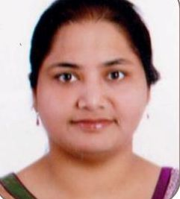 | 501642951575,  DRJPS6625A,  008010100176125,  AXIS BANK
S.NO | NAME OF THE TEACHER | DESIGNATION | QUALIFICATION WHETHER HAVING MBA I CLASS | WHETHER HAVING Ph.D DEGREE IN MANAGEMENT | DATE OF BIRTH | TOTAL NO OF YEARS OF EXPERIENCE |  | NATURE OF APPOINTMENT |  |  |  |  |  | PHOTO | DETAILS OF AADHAAR CARD,  PAN CARD,  BANK ACCOUNT NO
 |  |  |  |  |  |  |  | THROUGH O.U SELECTION COMMITTEE |  | MANAG  EMENT |  |  |  | PHOTO | DETAILS OF AADHAAR CARD,  PAN CARD,  BANK ACCOUNT NO
7 | Mrs. ARSHIYA JABEEN | Assistant Professor | MBA. | No | ’01-06-1976 | 08 |  |  |  |  |  |  |  | 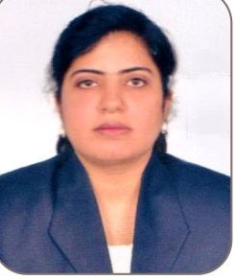 | 322857177806,  COTPS7097L,  807303599,  INDIAN BANK.
8 | Mrs. HUSNA FAKEHA | Assistant Professor | MBA. | No | ’10-09-1986 | 06 |  |  |  |  |  |  |  | 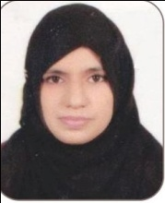 | 567091480449,  ACNPF4132H,  860910110009914  BANK OF INDIA
9 | Ms. NOUREEN SHADAN | Assistant Professor | MBA. | No | ’19-06-1990 | 06 |  |  |  |  |  |  |  | 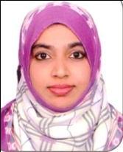 | 823367246467,  FFJPS7093E,  084010100006755  Andhra bank
S.NO | NAME OF THE TEACHER | DESIGNATION | QUALIFICATION WHETHER HAVING MBA I CLASS | WHETHER HAVING Ph.D DEGREE IN MANAGEMENT | DATE OF BIRTH | TOTAL NO OF YEARS OF EXPERIENCE |  | NATURE OF APPOINTMENT |  |  |  |  |  | PHOTO | DETAILS OF AADHAAR CARD,  PAN CARD,  BANK ACCOUNT NO
 |  |  |  |  |  |  |  | THROUGH O.U SELECTION COMMITTEE |  |  | MANAG  EMENT |  |  | PHOTO | DETAILS OF AADHAAR CARD,  PAN CARD,  BANK ACCOUNT NO
10 | Ms. AYESHA JABEEN | Assistant Professor | MBA. | No | ’20-04-1989 | 06 |  |  |  |  |  |  |  | 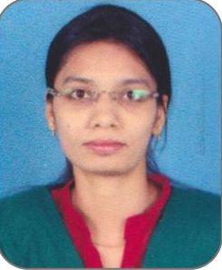 | 573241724539,  BJWPM8841F,  180601502848  Icici bank
11 | Ms. REHANA SULTANA | Assistant Professor | MBA. | No | ’11-05-1985 | 02 |  |  |  |  |  |  |  | 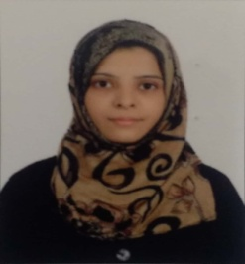 | 551974213495,  JNZPS6363B,  1622101016091,  Canara bank.
12 | Mrs. JUVERIA JAFFER | Assistant Professor | MBA. | No | ’25-08-1986 | 09 |  |  |  |  |  |  |  | 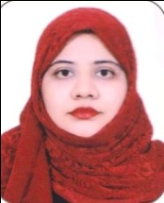 | 511156604632, BPDPJ0400C ,  798101059770,  CANARA BANK
S.NO | NAME OF THE TEACHER | DESIGNATION | QUALIFICATION WHETHER HAVING MBA I CLASS | WHETHER HAVING Ph.D DEGREE IN MANAGEMENT | DATE OF BIRTH | TOTAL NO OF YEARS OF EXPERIENCE | NATURE OF APPOINTMENT |  |  |  |  |  | PHOTO |  | DETAILS OF AADHAAR CARD,  PAN CARD,  BANK ACCOUNT NO
 |  |  |  |  |  |  | THROUGH O.U SELECTION COMMITTEE |  | MANAG  EMENT
13 | Mrs. SHAHANAZ BEGUM | Assistant Professor | MCA , MBA. | No | ’19-06-1984 | 11 |  |  |  |  |  |  | 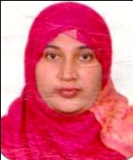 |  | 957691209609,  COWPB3678H,  403153518  Indian bank
14 | Mrs. Saba Mahmood- Al Amoodi | Assistant Professor | MBA. | No | 05-02-1987 | 08 |  |  |  |  |  |  | 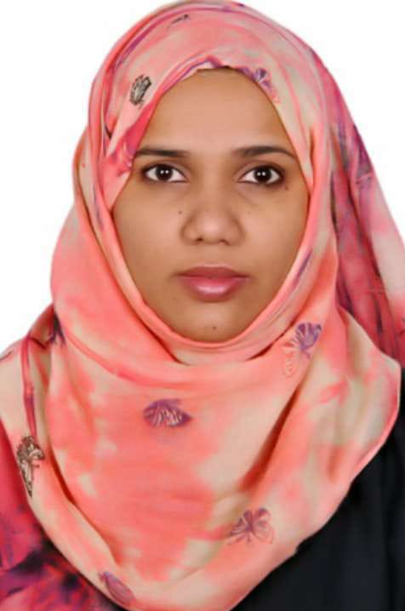 |  | 243748591788,  BEKPA3064B,  6104068334  IDBI BANK
15 | Ms. RIZWANA SULTANA | Assistant Professor | MCA. | No | 05-02-1987 | 08 |  |  |  |  |  |  | 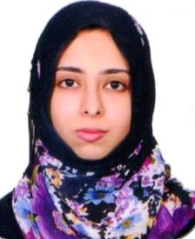 |  | 357467860986,  GLYPS5569H,  1622101020161  Canara bank

